**Driven Damped Harmonic Oscillations**

**Introduction**

The oscillator consists of an aluminum disk with a pulley that has a string wrapped around it to two springs. The angular positions and velocities of the disk and the driver are recorded as a function of time using two Rotary Motion Sensors. The amplitude of the oscillation is plotted versus the driving frequency for different amounts of magnetic damping. Increased damping is provided by moving an adjustable magnet closer to the aluminum disk.

**Equipment**

|  |  |  |
| --- | --- | --- |
| Quantity | Name | Model N0. |
| 2 | Rotary Motion Sensors | PS-2120 |
| 1 | Mechanical Oscillator/Driver | ME-8750 |
| 1 | Chaos Accessory | CI-6689A |
| 1 | Large Rod Stand | ME-8735 |
| 2 | 120-cm Long Steel Rods | ME-8741 |
| 1 | 45-cm Long Steel Rod | ME-8736 |
| 2 | Multi Clamps | ME-9507 |
| 1 | Physics String | SE-8050 |
| 5 | plastic shims of various thickness |  |
| 1 | 20 g Hooked Mass |  |
| 1 | 850 Universal Interface | UI-5000 |
| 1 | PASCO Capstone | UI-5400 |

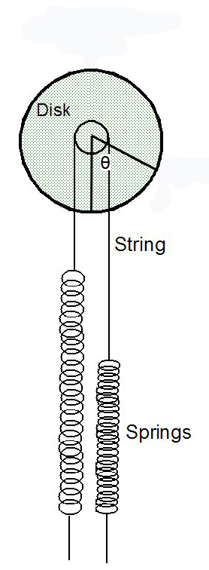

**Theory**

The oscillating system in this experiment consists of a disk connected to two springs. A string connecting the two springs is wrapped around the disk so the disk oscillates back and forth. This is like a torsion pendulum. The period of a torsion pendulum without damping is given by

$T=2π\sqrt{\frac{ I }{ κ }}$ (1)

wrhee I is the rotational inertia of the disk and  is the effective torsional spring constant of the springs. The rotational inertia of the disk is found by measuring the disk mass (M) and the disk radius (R). For a disk, oscillating about the perpendicular axis through its center, the rotational inertia is given by

$I=\frac{1}{2}MR^{2}$ (2)

The torsional spring constant is determined by applying a known torque ( = rF) to the disk and measuring the resulting angle (θ) through which the disk turns. Then the spring constant is given by

$κ=\frac{τ}{θ}$ (3)

If a damped oscillator is displaced from equilibrium and allowed to oscillate and damp out, the equation of motion is

$\frac{d^{2}θ}{dt^{2}}+\left(\frac{b}{I}\right)\frac{dθ}{dt}+\left(\frac{κ}{I}\right)θ=0$ (4)

The solution to this equation is a damped sine wave:

$θ=θ_{o}e^{-\left(\frac{b}{2I}\right)t}sin⁡(ωt+φ)$ (5)

where the angular frequency is given by

$ω=\sqrt{\frac{κ}{I}-\frac{b^{2}}{4I^{2}}}$ (6)

When the damped oscillator is driven with a sinusoidal torque, the differential equation describing its motion is

$I\frac{d^{2}θ}{dt^{2}}+b\frac{dθ}{dt}+κθ=τ_{o}cos⁡(ωt)$ (7)

The solution to this equation is

$θ=\frac{{τ_{o}}/I}{\sqrt{{\left(ω^{2}-ω_{o}^{2}\right)}^{2}+{\left(b/I\right)}^{2}ω^{2}}}cos⁡(ωt-φ)$ (8)

where the amplitude of the oscillation is $θ_{o}=\frac{{τ_{o}}/I}{\sqrt{{\left(ω^{2}-ω_{o}^{2}\right)}^{2}+{\left(b/I\right)}^{2}ω^{2}}}$ (9)

and $φ=\tan^{-1}\left(\frac{ωb/I}{ω_{o}^{2}-ω^{2}}\right)$ (10)

is the phase difference between the driving torque and the resultant motion. The resonant frequency, ωo, is given by

$ω_{o}=\sqrt{\frac{κ}{I}}$ $ω_{o}=\sqrt{κ/I}$ (11)

When the driving frequency is equal to the resonant frequency, the amplitude is a maximum. Setting ω = ωo in Equation (9),

$θ_{o}=\frac{τ_{o}}{b}\sqrt{I/κ}$ (12)

Examine the dependence of the phase difference, φ, on the driving frequency:

1. As the driving frequency () approaches zero, $φ=\tan^{-1}\left(0\right)→0$. The resulting motion is in phase with the driving torque.

(ii) At resonance,  = o, which results in

$θ=\frac{τ_{o}}{b}\sqrt{I/κ}cos\left(ω_{o}t-φ\right)$ and $φ=\tan^{-1}\left(\frac{2ω_{o}b/I}{ω_{o}^{2}-ω_{o}^{2}}\right)=\tan^{-1}\left(∞\right)=\frac{π}{2}$

(iii) As the driving frequency () goes to infinity, $φ=\lim_{ω→∞}\left[\tan^{-1}\left(\frac{2ωb/I}{ω_{o}^{2}-ω^{2}}\right)\right]=\tan^{-1}(-∞)=π$. The resulting motion is 180o out of phase with the driving torque.

**Set-Up**

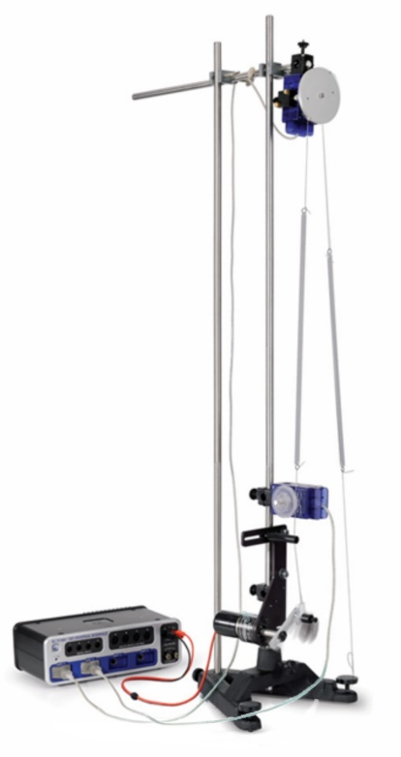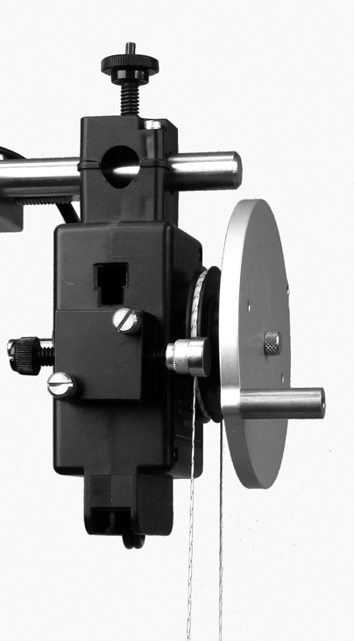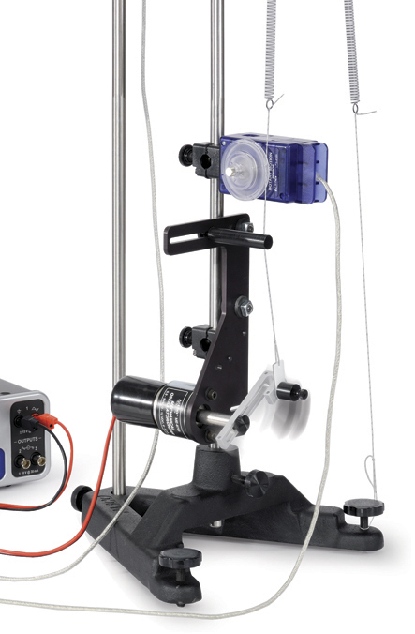

*Figure 1. Driver (the motor and arm just above the triangular stand)*

*Figure 3. String and Magnet*

*Figure 2. Complete Setup*

1. Mount the driver on a rod base as shown in Figure 1. Set the driver arm amplitude at about half maximum. Slide the first Rotary Motion Sensor onto the same rod as the driver. See Figure 2 for the orientation of the Rotary Motion Sensor.

2. On the driver, rotate the driver arm until it is vertically downward. Attach a string to the driver arm and thread the string through the string guide at the top end of the driver. Wrap the string completely around the Rotary Motion Sensor large pulley. Tie one end of one of the springs to the end of this string. Tie the end of the spring close to the Rotary Motion Sensor.

3. Use two vertical rods connected by a cross rod at the top for greater stability. See Figure 2.

4. Mount the second Rotary Motion Sensor on the cross rod.

5. Tie a short section of string (a few centimeters) to the leveling screw on the base. Tie one end of the second spring to this string.

6. Cut a string to a length of about 125 cm. Wrap the string around the large pulley of the second Rotary Motion Sensor twice (or more as long as it doesn’t slip). See Figure 3. Attach the disk to the Rotary Motion Sensor with the screw.

7. To complete the setup of the springs, thread each end of the string from the pulley through the ends of the springs and tie them off with about equal tension is each side: The disk should be able to rotate 180 degrees to either side without the springs hitting the Rotary Motion Sensor pulley.

8. Attach the magnetic drag accessory to the side of the Rotary Motion Sensor as shown in Figure 3. Adjust the screw that has the magnet so the magnet is about 1.0 cm from the disk. (The magnet on the pulley is to generate the damping force. Adjusting the distance between the magnet and disk can alter the magnitude of the damping force.)

9. Plug the disk Rotary Motion Sensor into Channel P1 and plug the driver Rotary Motion Sensor into Channel P2. Set the sample rate for both rotary motion sensors to 50 Hz.

10. Test the direction of the rotary motion sensors to make sure they read positive in the same direction. To do this, start recording and manually rotate the driver arm about half a turn and then stop recording. In order to check if two rotary sensors had the same direction, click the record button and manually rotate the driver arm about 180 degrees. Click the Hardware Setup in the tools column and check "Change Sign" if they didn't have the same direction, then it would be easy for us to analyze data later. If they do not, open the properties for one of the rotary motion sensors in the Data Summary and check "Change Sign". (Click the Hardware Setup in the tools column and check "Change Sign" if they didn't have the same direction)

11. In the Hardware Setup in PASCO Capstone, click on Signal Generator #1 and choose the Output Voltage/Current Sensor. Connect the banana cords from the driver to Signal Generator #1 on the 850 Universal Interface. In the Signal Generator setup, set Signal Generator #1 to a Negative Ramp with frequency of 0.001 Hz and an amplitude of 3.1 V. Also set the DC offset of 6.1 V. Set the signal generator on Off. These voltages control the speed of rotation of the driver.

12. In PASCO Capstone, set a stop condition in the Sampling Control bar. Set it to stop when the Output Voltage falls below 3.1V.

13. Click calculator, choose self-define or choose any formula showed on UI, edited the formula, enter [] to get choices. Create the following calculations:

AngVel=derivative(5,[Disk Angle, Ch P1(rad), ▼],[Time(s), ▼])

Angle Amp=amplitude(15,10,2,[Disk Angle, Ch P1(rad), ▼])

DriverAngVel=derivative(5,[Driver Angle, Ch P2(rad), ▼],[Time(s), ▼])

Driving Frequency=1/period(10,10,2,[Driver Angle, Ch P2(rad), ▼])

freq=smooth(29,[Driving Frequency(Hz), ▼])

**Procedure**

1. Resonant Frequency: Rotate the disk to some position and release. Then you could get a graph of angular speed of the disk versus time on the computer. Then stop recording. Measure the period using the coordinates tool on the PASCO Capstone graph.
2. Spring Constant: Attach the golden cylinder to one of the springs and hold it. It was essential that you were supposed to click the record button first, otherwise the graph would have some problems. After it recorded for a while, release the golden cylinder and then the disk started oscillating. Until the oscillation stopped, click the stop button. Remove the cylinder. Measure the radius of the groove of the large pulley and calculate the torque caused by the weight of the cylinder. Calculate the torsional spring constant using Equation (3).
3. Disk Rotational Inertia: Remove the disk from the second Rotary Motion Sensor, measure the mass, the radius of the disk and calculate its rotational inertia.
4. Resonance Curves: find the 6mm glass sheet. You needed to measure it again because some of the glass sheets weren't that precise. Put the magnet on the second Rotary Motion Sensor and insert the 6mm sheet between the disk and the magnet. Screw the screw until the magnet touched the sheet. Adjust the signal generator to 'Auto'. Click record and wait patiently. There might be nothing on the graph at first, it would appear in about 2 minutes. When the driving voltage dropped below 3. IV, it would stop automatically. Then you repeated the process with distance 4mm and 3mm between the magnet and the disk respectively.
5. Damping Coefficient: For the last experiment with 3mm damping distance, instead of using the Mechanical Driver, rotated the disk about 360 degrees manually and held it. Start recording first and then let go of the disk. When the disk stopped, click the stop button. Apply a damped sine curve to fit the graph and record the coefficients. Compare to the theory and calculate the damping coefficient (b).

**Analysis**

1. Using the torsional spring constant and the disk rotational inertia, calculate the theoretical period and the resonant frequency of the oscillator (ignoring friction).
2. Examine the resonance curves for different amounts of damping. How does increasing the damping affect the shape of the curve (the width, maximum amplitude, frequency of the maximum)?
3. Is the resonant frequency for the least amount damping the same as the theoretical frequency? Calculate the percent difference.
4. Why is the resonance curve asymmetrical about the resonant frequency?
5. Apply a User-Fit to the 3 mm resonance curve in the form of the amplitude function given in Equation (9). Use the fit parameters to determine the resonant frequency and the damping coefficient. Remember that the frequency (f) plotted is related to the angular frequency (ω) by ω=2πf.
6. Create a graph of Disk Angular Velocity and Driver Angular Velocity vs. time. Examine the graphs of the driving oscillation versus time and the disk oscillation versus time. Measure the phase difference between these oscillations at high frequency (at the beginning of the time), resonance frequency (at the time when the disk oscillation is greatest), and at low frequency (at the end of the time). Do these phase differences agree with the theory?